Standard: MS-LS1-2. Develop and use a model to describe the function of a cell as a whole and ways parts of cells contribute to the function.
LS1.A: Structure and Function • Within cells, special structures are responsible for particular functions, and the cell membrane forms the boundary that controls what enters and leaves the cell.

E.Q. While outlaws are typically thought of in a negative light, they sometimes have redeeming qualities that provide balance. Robin Hood is a fictitious outlaw who sought to restore balance. Balance within a cell is referred to as homeostasis. While the organelle you have been assigned may be the most ruthless outlaw on Organelle Trail, what redeeming quality does your organelle have that provides balance to the cell?

Grab yer hat and saddle the broncs! It’s time to head down the Organelle Trail!
You’ve just been made a U.S. Marshall!

Now that you are a U.S. Marshall, your job is to gather all of the information you can about a WANTED organelle. At the end of this “cyber trail”, you will need to whip up a WANTED poster to show to the other U.S. Marshalls in your camp so that they will know how to look for your wanted organelle too! For this project I want you to think America’s Most Wanted – Wild West style!

Part 1: First Duties
- Receive your assigned organelle/structure. This will be provided in your briefing from the president (Ms. Calamity Jane)
Vacuoles Lysomes Ribsomes Endoplasmic Reticulum

Mitochondria Cell membrane Golgi Body (apparatus) Nucleus

Cell Wall Chloroplast

Assigned Organelle name

Part 2: Gather Your Facts
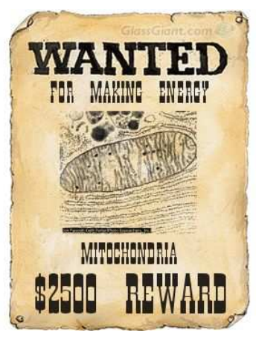
To complete your poster (and find your suspect), you will need to gather facts along the trail! As you gather facts, record the information on your FACT SHEET. You will need to know the following:

- CRIME: What has this organelle done?
  - Why is this organelle "wanted"? In other words, what does it do for the cell? Or, what is the organelle’s function?

- PHYSICAL DESCRIPTION: What does the organelle look like? How would you know if you found the organelle?
  - Provide a description and an actual picture. The picture must be a sketch from a sketch artist (hand drawn by you). Remember the more details you have, the easier it will be for others to identify!

- LOCATION: Where should we look for the organelle?
  - Which of the following types of cells is this organelle found in? Make sure that you have explored, bacteria (Archaebacteria and Eubacteria), Protists, Fungi, Plants, and Animals.

  - Where is the organelle located in the cell? (By other specific organelles? By the cell membrane? Floating in the Cytoplasm?)

- ACCOMPLICES: Who helps your organelle?
  - In other words, what other organelles/structures in the cell help your organelle do it’s job?

Part 3: Trail Sites

You will need to follow the “cyber” trails to find information about your wanted organelle. You do not need to visit each website. However, each website will offer information to help you gather your facts!

The Encyclopedia Britannica Online – ID – sunny Pass – days http://school.eb.com/levels/middle/article/cell/273572#9273572.toc

Ask A Biologist - https://askabiologist.asu.edu/content/cell-parts

Biology4kids.com - http://www.biology4kids.com/files/cell_main.html

Cells Alive! - http://www.cellsalive.com/cells/cell_model.htm

Virtual Investigations – Animal Cell https://my.hrw.com/content/hmof/science/high_school_sci/na/gr9-12/hmd_bio_9780547688442_/dlo/virtualinvestigations/b03_00vi07/index.html

MathXscience - http://www.mathxscience.com/cells.html

Biology Tutor - http://biology.tutorvista.com/cell/cell-structure.html?view=simple

CK-12 - http://www.ck12.org/book/CK-12-Life-Science-Concepts-For-Middle-School/section/2.5/

Learn Genetics – Inside a Cell - http://learn.genetics.utah.edu/content/cells/insideacell/

You must use at least 3 different resources for your information

Part 4: The Roundup
Share the information you have discovered by completing a “WANTED” poster for your organelle/structure. The poster should include, but is not limited to:

- A large “WANTED” displayed along with the name of your organelle (large, easy to read letters) … don’t forget to add the reward amount!

- A mug shot (printed picture) or a sketch from a sketch artist (hand drawn) of your organelle/structure (personification in your drawing is encouraged). Include one of just the organelle and one of the organelle in the cell

- Descriptive answers (in your own words!) to all 4 questions in Part 2. Please have this typed in an appropriate “Old West Wanted” language and font and glued to your poster. (Crime/Function, Description of appearance, location in types of cells and location in cell)

- An educated guess to the following question: What is the relationship between structure (the way the organelle looks) and function (the job the organelle does)? Or, does the way the organelle look help it do its job?

- Site the 3 sources you used on the back of your poster!!

For ideas or help in making your wanted poster, visit the following website (http://www.glassgiant.com/wanted/ ). Remember the more effort and creative

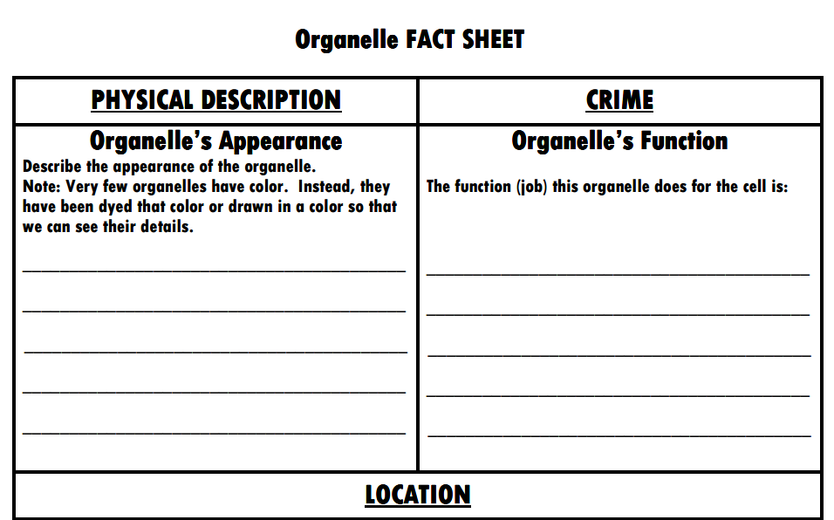
your poster is the better chance of getting full credit.

